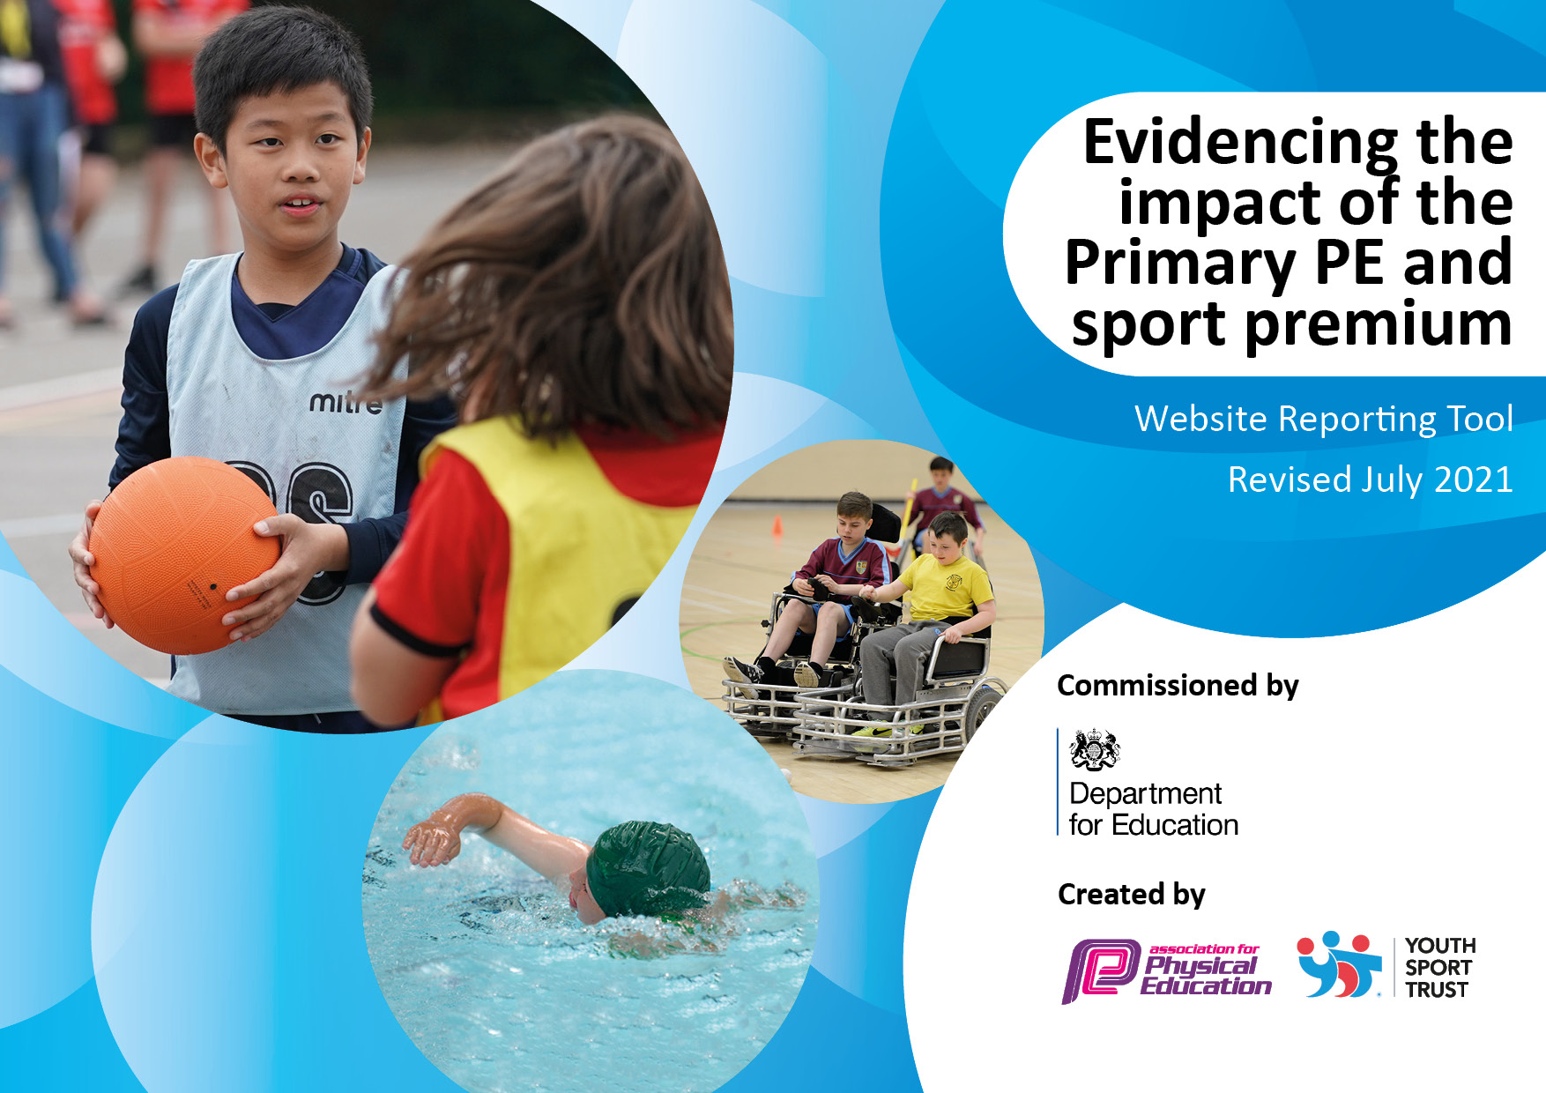

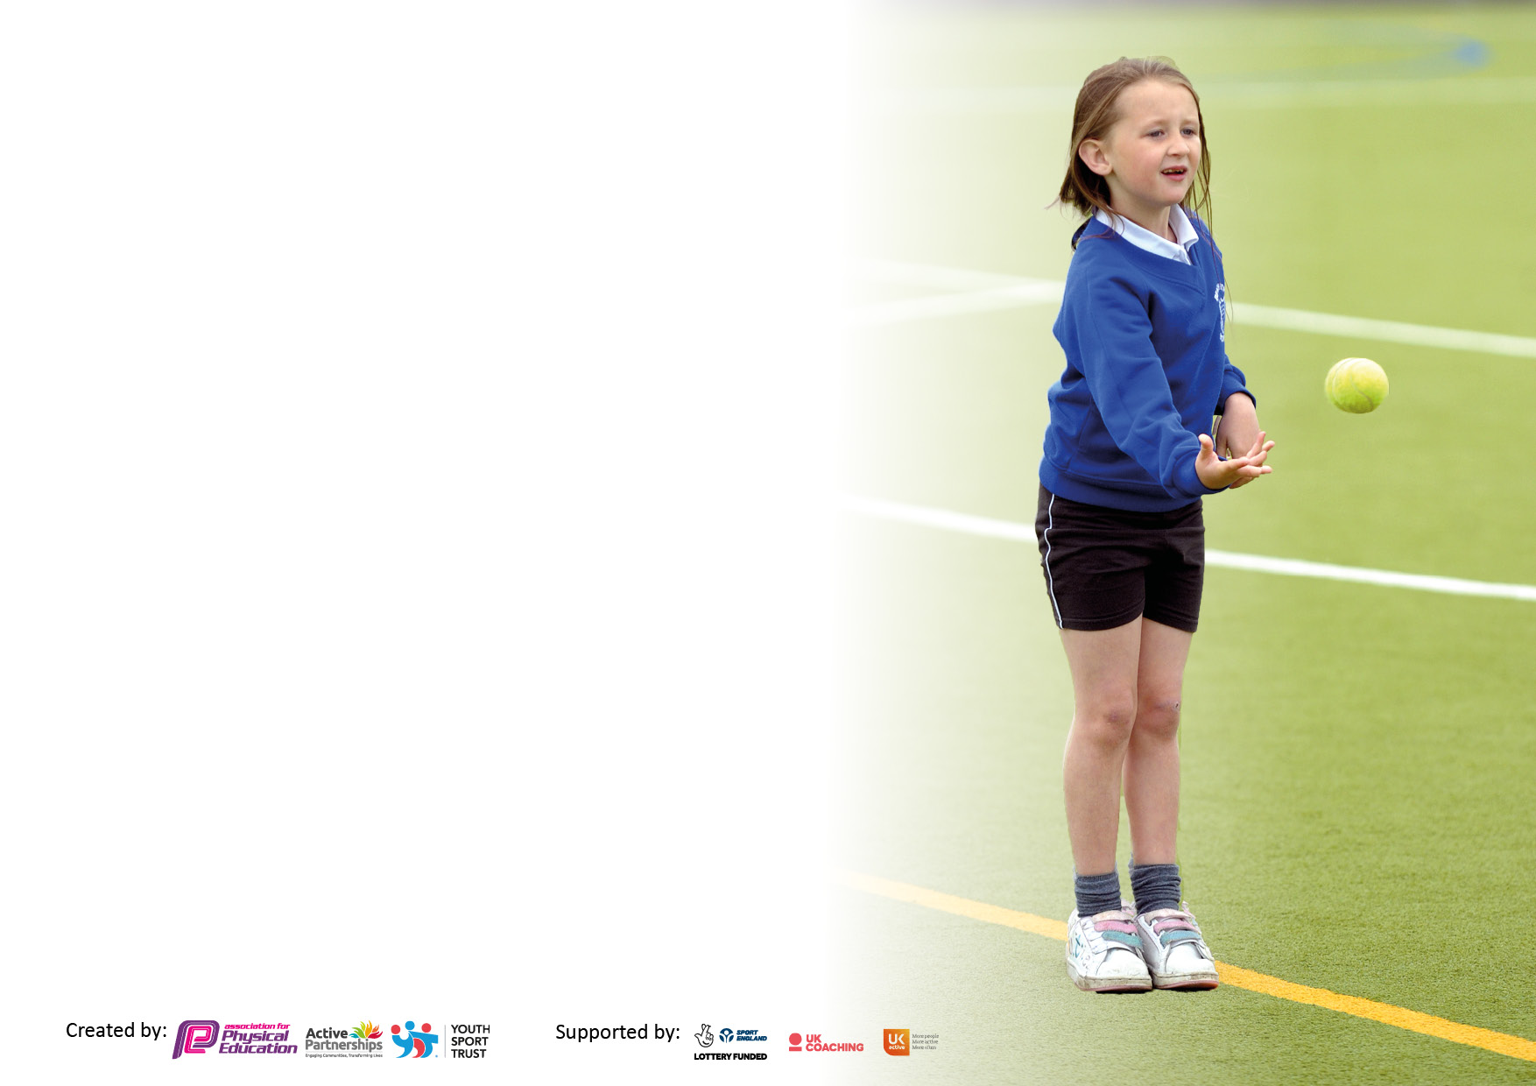

It is important that your grant is used effectively and based on school need. The [Education Inspection Framework](https://assets.publishing.service.gov.uk/government/uploads/system/uploads/attachment_data/file/843108/School_inspection_handbook_-_section_5.pdf) makes clear there will be a focus on **‘whether leaders and those responsible for governors all understand their respective roles and perform these in a way that enhances the effectiveness of the school’**.

Under the [Quality of Education](https://assets.publishing.service.gov.uk/government/uploads/system/uploads/attachment_data/file/843108/School_inspection_handbook_-_section_5.pdf) Ofsted inspectors consider:

**Intent** - Curriculum design, coverage and appropriateness

**Implementation** - Curriculum delivery, Teaching (pedagogy) and Assessment

**Impact** - Attainment and progress

To assist schools with common transferable language this template has been developed to utilise the same three headings which should make your plans easily transferable between working documents.

Schools must use the funding to make **additional and sustainable** improvements to the quality of Physical Education, School Sport and Physical Activity (PESSPA) they offer. This means that you should use the Primary PE and sport premium to:

* Develop or add to the PESSPA activities that your school already offer
* Build capacity and capability within the school to ensure that improvements made now will benefit pupils joining the school in future years
* The Primary PE and sport premium should not be used to fund capital spend projects; the school’s budget should fund these.

Pleasevisit[gov.uk](https://www.gov.uk/guidance/pe-and-sport-premium-for-primary-schools)fortherevisedDfEguidanceincludingthe5keyindicatorsacrosswhichschoolsshoulddemonstrate animprovement.Thisdocumentwillhelpyoutoreviewyourprovisionandtoreportyourspend.DfEencouragesschools to use this template as an effective way of meeting the reporting requirements of the Primary PE and sport premium.

We recommend you start by reflecting on the impact of current provision and reviewing the previous spend.

Schools are required to [publish details](https://www.gov.uk/guidance/what-maintained-schools-must-publish-online#pe-and-sport-premium-for-primary-schools) of how they spend this funding, including any under-spend from 2019/2020, as well as on the impact it has on pupils’ PE and sport participation and attainment. **All funding must be spent by 31st July 2022.**

We recommend regularly updating the table and publishing it on your website throughout the year. This evidences your ongoing self-evaluation of how you are using the funding to secure maximum, sustainable impact. Final copy must be posted on your website by the end of the academic year and no later than the 31st July 2021. To see an example of how to complete the table please click [HERE](http://www.afpe.org.uk/physical-education/wp-content/uploads/afPE-Example-Template-Indicator-2018-Final.pdf).



**Details with regard to funding**

Please complete the table below.

|  |  |
| --- | --- |
| Total amount carried over from 2019/20 | £10,000 |
| Total amount allocated for 2020/21 | £16906 |
| How much (if any) do you intend to carry over from this total fund into 2021/22? | £10,969 |
| Total amount allocated for 2021/22 | £17,045 |
| Total amount of funding for 2021/22. To be spent and reported on by 31st July 2022. | £28,014 |

**Swimming Data**

Please report on your Swimming Data below.

|  |  |
| --- | --- |
| Meeting national curriculum requirements for swimming and water safety.  N.B. Complete this section to your best ability. For example you might have practised safe self-rescue techniques on dry land which you can then transfer to the pool when school swimming restarts.  **Due to exceptional circumstances priority should be given to ensuring that pupils can perform safe self rescue even if they do not fully meet the first two requirements of the NC programme of study** |  |
| What percentage of your current Year 6 cohort swim competently, confidently and proficiently over a distance of at least 25 metres?  **N.B.** Even though your pupils may swim in another year please report on their attainment on leaving primary school at the end of the summer term 2020.  Please see note above | 89% |
| What percentage of your current Year 6 cohort use a range of strokes effectively [for example, front crawl, backstroke and breaststroke]?  Please see note above | 84% |
| **What percentage of your current Year 6 cohort perform safe self-rescue in different water-based situations?** | 79% |
| Schools can choose to use the Primary PE and sport premium to provide additional provision for swimming but this must be for activity **over and above** the national curriculum requirements. Have you used it in this way? | Yes/No |

**Action Plan and Budget Tracking**

Capture your intended annual spend against the 5 key indicators. Clarify the success criteria and evidence of impact that you intend to measure to evaluate for pupils today and for the future.

|  |  |  |  |  |
| --- | --- | --- | --- | --- |
| **Academic Year:** 2021/22 | **Total fund allocated: £**28014 (including carry forward) | **Date Updated: July 2022** | |  |
| **Key indicator 1:** The engagement of all pupils in regular physical activity – Chief Medical Officers guidelines recommend that primary school pupils undertake at least 30 minutes of physical activity a day in school | | | | Percentage of total allocation: |
| 41% |
| **Intent** | **Implementation** | | **Impact** |  |
| Your school focus should be clear what you want the pupils to know and be able to do and about  what they need to learn and to  consolidate through practice: | Make sure your actions to achieve are linked to your intentions: | Funding allocated: | Evidence of impact: what do pupils now know and what can they now do? What has changed?: | Sustainability and suggested next steps: |
| OPAL Outdoor Learning, an exciting new initiative for Hilltop, will help to support our ambition to have children active for 60 minutes per day.  Children will be active for at least 60 minutes of the day.  Children will develop ways to play.  All areas of the school playground will be accessed and used.  OPAL will promote wider school improvement, particularly surrounding behaviour during and after break/ lunch time. It will help to ensure children are ‘READY, RESPECTFUL AND SAFE’ as they enter the classroom after breaks.    Equipment and loose parts should be stored safely and effectively to keep the equipment in good condition and the school grounds tidy.  Increase the amount of physical activity the children do in their lunchbreak. | Ensure all staff are trained to use the OPAL programme. Middays TAs and other members of the OPAL working party will be paid for additional hours worked. Staffing cover for teachers will also be factored into the costing. This includes several training events:   * Development 1. * Risk Benefit training. * Development 2. * Grounds meeting * Whole-school staff inset * Development 3   Order a play shed to be placed on the playground for storage of equipment.  Order storage bins for loose parts.  Train students, staff and lunch time supervisors to use shed safely and effectively.  Employ staff so that equipment can be maintained to facilitate good play.  Improve the school grounds for OPAL related activities.  Employ a designated-sports and play leader for lunchtimes to increase the amount of physical activity the children do in their lunchbreak.  Play leader should effectively engage the children in active play.  Leader to target children that are identified as ‘inactive’ and/or ‘overweight’. | £210  £210  £210  £157.50  £315  £210  £2500  £500  Free  £1133.35  £3147.20  £2821 | Development 1, risk benefit training, development 2 and the grounds meeting have all been completed. Other meetings have been arranged for the coming academic year.  The OPAL working party has been created, including involvement of the school’s governing board (L.T), recruiting a play coordinator (H.W) and establishing an OPAL curriculum lead (S.G).  Many items have been added to our play equipment, including amongst other things: Hilltop Beach, Hilltop Hill, tyres, barrels, table tops, chairs and barriers.  The impact survey has been completed. We will re-complete this in the future to assess overall impact. However, it is clear from conversations with children and staff that the OPAL approach is making play more enjoyable and is promoting physical activity on the playground.  The shed and loose parts store is on order and will arrive shortly.  Play assemblies are held weekly on a Monday following the CINI format – celebrate, introduce, negotiate and innovate.  The role of sports leader and play leader have been tied together under the play coordinator role. This is allowing the play team to deliver effective play. H.W appointed. | Complete further training to extend to full staff body.  Install loose parts shed and train children and staff to use it.  Recomplete impact survey to quantify, if any, impact on enjoyment of play and physical activity.  Develop the OPAL curricular lead role further so that it is treated like a curriculum subject with ‘learning walks’ and monitoring cycles alongside school governance.  Continue to introduce new loose parts to keep play fun and exciting.  Continue to expand and develop school grounds. In the near future, we hope to add a digging pit and we have long term ambitions to create a wooded area in the school grounds.  Continue to employ a play co-ordinator for the foreseeable future. |
| **Key indicator 2:** The profile of PESSPA being raised across the school as a tool for whole school improvement | | | | Percentage of total allocation: |
| 25% |
| **Intent** | **Implementation** | | **Impact** |  |
| Your school focus should be clear what you want the pupils to know and be able to do and about  what they need to learn and to  consolidate through practice: | Make sure your actions to achieve are linked to your intentions: | Funding allocated: | Evidence of impact: what do pupils now know and what can they now do? What has changed?: | Sustainability and suggested next steps: |
| Celebrate achievement in sport to raise the profile across the school.  Communicate with parents on sporting achievements to raise the profile of sport within the whole-school community.  Improve the social, emotional and mental health (SEMH) of our children through forest schools.  For children that are able to access forest school, as their teacher is a qualified practitioner, assessments should demonstrate improvements in the following areas of SEMH:  - Self-awareness  - Self-regulation  - Social skills  - Empathy  - Confidence with staff  - Confidence with peers  - Well-being  - Challenge/ engagement  - General mood  Provide the full breadth of forest school provision that can be taught in EYFS.  Increase focus on positive learning behaviours using Commando Joes sessions. | Certificates to be handed out, during the celebration assembly, to every child who takes part in a competition with school.  Post to Dojo to inform parents about competitions.  Ensure there is sufficient equipment to teach forest schools. Ensure there is sufficient storage for equipment.  Develop Commando Joes – ‘RESPECT’ characters and characteristics:  R - resilience  E empathy  S self-awareness  P passion  E excellence  C communication  T teamwork | £0  £0  £1000  £6000 | Pupils have enjoyed having their sporting achievements celebrated during our celebration assemblies on Friday.  Parents have frequently been communicated with regarding achievements within sport via Class Dojo.  Children in Yellow Class thoroughly enjoy forest schools. It has dramatically impacted the intended areas of SEMH and as a result they are in a better position to learn when they enter the classroom.  Due to covid, the training was not able to take place when originally scheduled therefore the programme was not fully implemented. The training has now been given and Commando Joes will be implemented in the coming year. | Continue in the coming academic year.  Continue in the coming academic year.  Continue to replenish and buy new equipment as and when required.  Next year, we intend to formally assess the impact of forest schools on SEMH for the children that receive it.  Include Commando Joes within the 3-year rolling programme, tying it in with our curriculum for foundation subjects, where possible. |

|  |  |  |  |  |
| --- | --- | --- | --- | --- |
| **Key indicator 3:** Increased confidence, knowledge and skills of all staff in teaching PE and sport | | | | Percentage of total allocation: |
| 11% |
| **Intent** | **Implementation** | | **Impact** |  |
| Your school focus should be clear | Make sure your actions to | Funding | Evidence of impact: what do | Sustainability and suggested |
| what you want the pupils to know | achieve are linked to your | allocated: | pupils now know and what | next steps: |
| and be able to do and about | intentions: |  | can they now do? What has |  |
| what they need to learn and to |  |  | changed?: |  |
| consolidate through practice: |  |  |  |  |
| Increase the knowledge and confidence of all staff to deliver sports-based PE lessons by allowing them to observe, shadow and question specialist sports coaches.  Staff will feel more confident to deliver sports from the observations they make.  Ensure the leadership of PE is effective through teacher release periods.  Observe lessons and look at the leadership of PE with Quentin Hannant – Education Improvement Service.  Monitor PE through learning walks and feedback on these.  Analyse and scrutinise spending of school sports premium.  Buy into a designated PE scheme that supports teachers with the effective planning and delivery of the PE curriculum, that meets our ‘intent’. | Liaised with Primary Stars leader, Rob, who is a qualified PE teacher to arrange a total of 38 sessions of PE. This means each teacher will get to observe a specialist for 2 full half-terms.  Discussions with Rob highlighted the need for the coaches to support the staff as well as teaching the children.  Staff were given the option to choose 2 sports from the rolling programme that they felt they were the least competent in delivering, so they could receive support in these areas.  Employ specialised sports coaches from Primary Stars to deliver PE sessions during their timetabled slot to free S.G up. Total = 6 hours. Pay HLTA (K.S) 1 hour for class cover.  Subscribe to Complete PE.  Liaise with members of staff working for Complete PE to deliver a website and planning run through.  Incorporate the scheme into the school’s PE rolling cycle.  Marry the planning up to the events package delivered by QEGS so that lessons prepare children adequately for events. | £1852.5  £307.50  £975 | Staff have found the support from the Primary Stars coaches extremely helpful in developing their competence and pedagogies in many sports. Teachers have begun to use the ideas and tips from the coaches in their own lessons. We look to continue similar support in the future.  Leadership time has been used effectively to develop a number of areas for sport and physical activity at Hilltop. Tasks completed:   * Effective use of sports premium. * OPAL set up and running with help of play coordinator. * Audited equipment and purchased new. * Scheduled a number of sporting events. * Created new 3-year cycle. * Researched, purchased and booked training for a sports-based PE scheme. * Planned a successful sports day.   Complete PE has now been purchased and fully integrated into our 3-year rolling plan. We are yet to reap the rewards of this scheme as we are due to fully initiate in it in September, however from trial lessons, teachers have anecdotally reported positive results, with the planning helping to improve their confidence and quality in delivery. | Review the new rolling programme for PE and highlight where staff lack confidence. Arrange for sessions with Primary Stars and other organisations, with the emphasis on upskilling our teachers.  Continue to book leadership time for PE 1-2 times per half-term in the coming year.  Pay the annual subscription fee of £150. |
| **Key indicator 4:** Broader experience of a range of sports and activities offered to all pupils | | | | Percentage of total allocation: |
| 16% |
| **Intent** | **Implementation** | | **Impact** |  |
| Your school focus should be clear | Make sure your actions to | Funding | Evidence of impact: what do | Sustainability and suggested |
| what you want the pupils to know | achieve are linked to your | allocated: | pupils now know and what | next steps: |
| and be able to do and about | intentions: |  | can they now do? What has |  |
| what they need to learn and to |  |  | changed?: |  |
| consolidate through practice: |  |  |  |  |
| Give students the basic skills to safely ride a bike – including experience on the road.  All children should be able to ride a bike. The majority of the children involved should be able to ride on the roads safely.  Offer a range of enjoyable afterschool clubs, taught by qualified coaches, to broaden children’s experiences in sport outside of school hours.  Keep costs of afterschool clubs low, to ensure that all children can attend, particularly those from less affluent backgrounds.  Increase the quality of our swimming provision so that children are confident using a range of strokes and can competently swim over a distance of at least 25m.  This will be offered to year 3 pupils during the winter term only – additional catch up following covid-related disruptions.  Our year 3 cohort should be able to confidently swim.  Children should be able to know and use a range of swimming strokes.  All children should recognise the importance of water safety and appreciate why swimming is a key skill.  Some children may start to ‘self-rescue’.  Purchase equipment so that all lessons within the new 3-year cycle for PE can be delivered effectively and with the appropriate amount of equipment for each class.  Educate children about the benefits of a healthy active lifestyle.  Provide the year 6s with a sports-based enrichment opportunity post-SATs to support well-being and enjoyment of sport. | Level 1 and 2 bikeability course booked through Cycle Derby for all year 6 students.  Hire bikes, including an adapted bike for a wheelchair user.  Arranged 37 sessions with Primary Stars. These sessions were predominantly paid for by parents, however to ensure they could still go ahead, the difference was subsidised by the sports premium.  Pay 2 qualified swimming coaches who have extensive knowledge of teaching swimming and hire the pool.  Hire a bus to return the children to school (they get dropped off at the pool by parents).  Pay for a TA to support the children and swimming coaches during the delivery.  Complete an equipment audit.  Look at the rolling cycle and judge if we have enough equipment to teach each lesson.  Identify short comings in equipment.  Order equipment.  Research companies that deliver health-based school workshops.  Book an hour long slot for each class.  Book an archery class. | Free  £100  £907.50  £500  £448  £324.60  £2000  £150  £75 | All children that took part in the cycling programme were able to safely ride a bike on the road.  The year 6s thoroughly enjoyed taking part in the bikeability course, taught by Cycle Derby.  Children thoroughly enjoyed taking part in the afterschool clubs this year. This has allowed them to experience activities they wouldn’t have otherwise experienced. Some children have also taken up these activities out of school too – promoting healthy active lifestyles.  The majority of the cohort could enter the water and swim confidently by the end of the swimming lessons. Some children have taken up swimming outside of school too.  The equipment has been purchased and this is allowing teachers to deliver lessons more effectively, using the appropriate equipment.  The children enjoyed taking part in a ‘Fit4Life’ workshop delivered by Progressive Sports as part of our school’s healthy week. Afterwards, they were able to identify some of the benefits of physical activity and were able to use the ‘Eat Well’ chart to describe what a healthy balanced diet should consist of.  The year 6 children enjoyed letting their hair down after a busy week – it put the smiles back on their faces. | We intend to rebook this for our next year 6 cohort, as soon as Cycle Derby receive their funding allocation for the next academic year.  Book a variety of afterschool clubs next year.  Once this year has been completed, we will be moving our swimming provision to the year 4 cohort each year. Swimming will therefore commence in the academic year 2023/24.  Continue to audit equipment at the end of each year, account for damaged equipment and order new if required.  We are looking to make healthy week and annual event and will look to book similar activities in the future.  Book a similar opportunity next year. |

|  |  |  |  |  |
| --- | --- | --- | --- | --- |
| **Key indicator 5:** Increased participation in competitive sport | | | | Percentage of total allocation: |
| 7% |
| **Intent** | **Implementation** | | **Impact** |  |
| Your school focus should be clear | Make sure your actions to | Funding | Evidence of impact: what do | Sustainability and suggested |
| what you want the pupils to know | achieve are linked to your | allocated: | pupils now know and what | next steps: |
| and be able to do and about | intentions: |  | can they now do? What has |  |
| what they need to learn and to |  |  | changed?: |  |
| consolidate through practice: |  |  |  |  |
| Increase the number of inter-school competitions that children get to attend.  This will provide children with a valuable opportunity to use and celebrate their super skills learnt in P.E lessons against other schools and children.  It will help to increase the confident of some children.  Those on the gifted and talented register for P.E will be given the opportunity to ‘shine’.  Children will develop social skills and sportsmanship.  Hold intra-school competition through a sports day event.  All children should be given the chance to succeed and be celebrated.  Beside celebrating victories, the competition should mainly be aimed at promoting our school growth-mindset values and good sportsmanship. | Join the QEGS primary school’s competition package (only covers KS2)  Sign-up to Primary Stars KS1 and reception events to ensure all children are given the opportunity to compete.  Hire a bus to attend all events.  Pay staff through additional hours worked to support at events.  Arrange a school sports day.  Buy resources for house items and colours.  Invite parents to attend.  Have the field marked out with a running track. | £200  £176.60 cross country  £109.50 football  £160.30 Mini athletics  £700  £300  £0  £400  £0  Free – part of DDCC grounds contract. | The children have attended nearly all of the events hosted by QEGS and Primary Stars this year. It has helped to develop their team working abilities, sportsmanship and has promoted an enjoyment of sport. We intend to continue this next year.  The children loved sports day and many parents named it the best one yet – we created a carousel of a range of fun activities. The less confident children were able to take part without feeling hundreds of eyes watching them. | We have already signed up to QEGS and Primary Stars competition packages for the coming year. Buses and staff cover to be arranged shortly.  We will use the same format next year but will change the events. There will be no reoccurring costs. |

|  |  |
| --- | --- |
| Signed off by | |
| Head Teacher: | D.Hooley |
| Date: | 21/07/2022 |
| Subject Leader: | S.W.Greatorex |
| Date: | 21/07/2022 |
| Governor: | Next AGM meeting 19.09.2022 |
| Date: | Next AGM meeting 19.09.2022 |