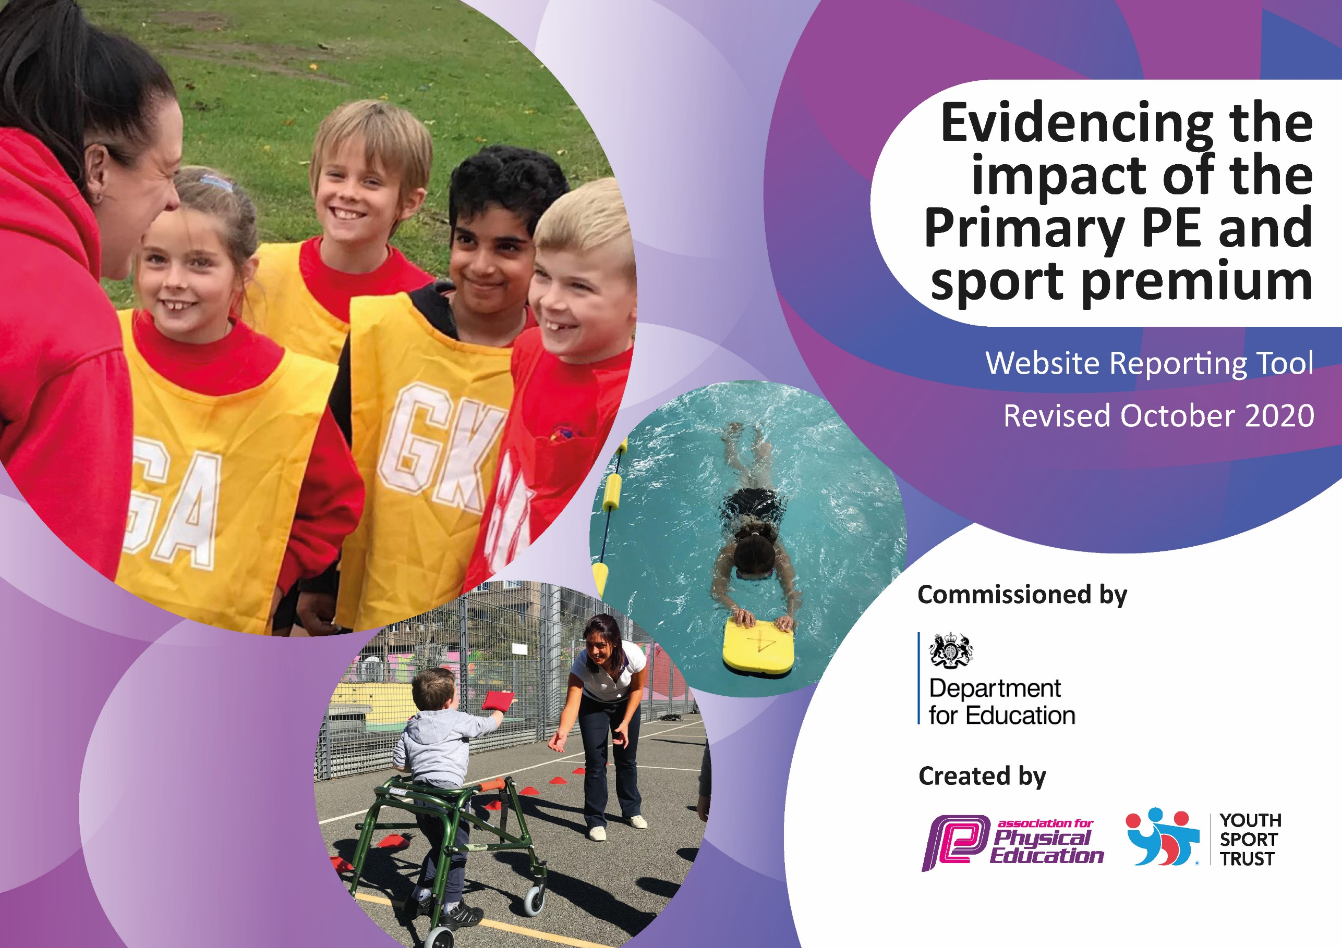
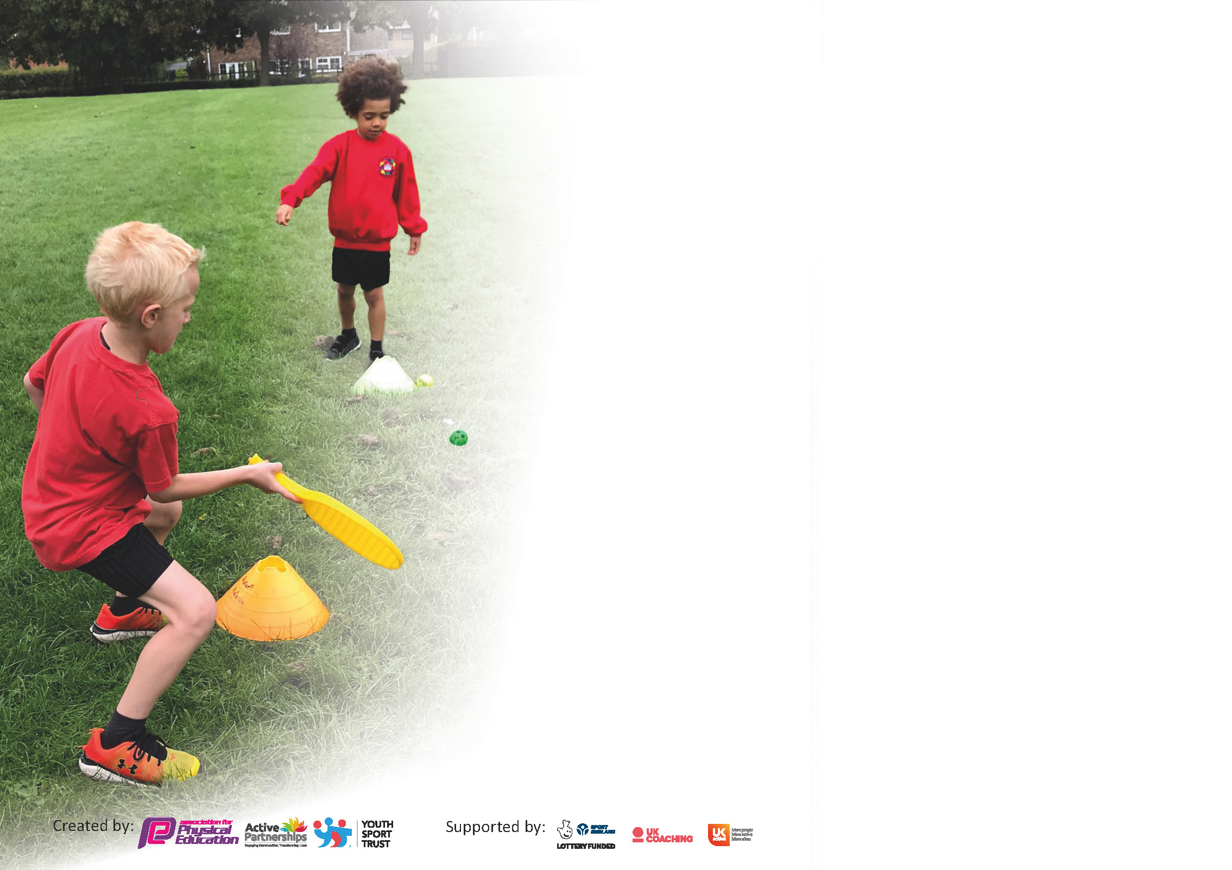

It is important that your grant is used effectively and based on school need. The Education Inspection Framework (Ofsted 2019 p64) makes clear there will be a focus on ‘whether leaders and those responsible for governors all understand their respective roles and perform these in a way that enhances the effectiveness of the school’.

Under the Quality of Education criteria (p41) inspectors consider the extent to which schools can articulate their curriculum (INTENT), construct their curriculum (IMPLEMENTATION) and demonstrate the outcomes which result (IMPACT).

To assist schools with common transferable language this template has been developed to utilise the same three headings which should make your plans easily transferable between working documents.

Schools must use the funding to make additional and sustainable improvements to the quality of Physical Education, School Sport and Physical Activity (PESSPA) they offer. This means that you should use
the Primary PE and sport premium to:

- Develop or add to the PESSPA activities that your school already offer
- Build capacity and capability within the school to ensure that improvements made now will benefit pupils joining the school in future years

Please visit gov.uk for the revised DfE guidance including the 5 key indicators across which schools should demonstrate an improvement. This document will help you to review your
provision and to report your spend. DfE encourages schools to use this template as an effective way of meeting the reporting requirements of the Primary PE and sport premium.

We recommend you start by reflecting on the impact of current provision and reviewing the previous spend.

Schools are required to publish details of how they spend this funding as well as on the impact it has on pupils’ PE and sport participation and attainment by the end of the summer term or by 31st July 2021 at the latest.

** In the case of any under-spend from 2019/20 which has been carried over this must be used and published by 31st March 2021.

We recommend regularly updating the table and publishing it on your website throughout the year. This evidences your ongoing self-evaluation of how you are using the funding to secure maximum, sustainable impact. Final copy must
be posted on your website by the end of the academic year and no later than the 31st July 2021. To see an example of how to complete the table please click HERE.
Created by: Supported by:

Please note: Although there has been considerable disruption in 2020 it is important that you publish details on your website of how you spend the funding - this is a legal requirement.
Support for review and reflection - considering the 5 key indicators from DfE, what development needs are a priority for your setting and your pupils now and why? Use the space below to reflect on previous spend and key achievements and areas for development.

N.B. In this section you should refer to any adjustments you might have made due to Covid-19 and how these will influence further improvement.
Key achievements to date until July 2020: | Areas for further improvement and baseline evidence of need:
A broad range of sporting activities have been offered during after-school clubs.  Achieved the Derbyshire Reward and Recognition Award (it was not possible to achieve School Games Mark Gold Award due to Covid-19).  Children more physically active during play times.  Given school closures, we feel that the number of our year 2 cohort, that can swim confidently, is good.  Wheels ‘set in motion’ for implementation of Real PE across the whole school – we feel this scheme is extremely good not just for PE, but for supporting the wider curriculum. | Ensure all staff are trained in, and can deliver, Real PE successfully.  Enter more whole classes into competitions.  Further increase the amount of time children spend physically active during the school day. Potentially implement a golden mile to help achieve this.  More equipment needed to ensure all sports can be delivered to whole classes during PE.  Increase the competency of our staff to deliver PE to a good level.  Employ a designated sports leader for play times.

Did you carry forward an underspend from 2019-20 academic year into the current academic year? YES

If YES you must complete the following section.
If any funding from the academic year 2019/20 has been carried over you MUST complete the following section. Any carried over funding MUST be spent by 31 March 2021.
Academic Year: September 2020 to March 2021 | Total fund carried over: £10,000 | Date Updated:  October 2020
What Key indicator(s) are you going to focus on? |  |  |  | Total Carry Over Funding:
 |  |  |  | £10,000
Intent | Implementation |  | Impact
Your school focus should be clear how you want to impact on your pupils. | Make sure your actions to achieve are linked to your intentions: | Carry over funding allocated: | Evidence of impact: How can you measure the impact on your pupils; you may have focussed on the difference that PE, SS & PA have made to pupils re-engagement with school. What has changed?: | Sustainability and suggested next steps and how does this link with the key indicators on which you are focussing this academic year?:
Indicator 1  Maximise the use of outdoor areas that have been, so far, somewhat limited due to covid-19.  Acquire play equipment to improve the levels of physical activity during play and dinnertime.  OPAL Outdoor Learning, an exciting new initiative for Hilltop, will help to support our ambition to have children active for 60 minutes per day. | Purchase 2 welly racks so that we have more outdoor spaces available to use during break and dinner times.  ‘TAG Team trail’ markings to be installed on the playground by Thermmark. This set up is a race type one that encourages physical activity. It includes running, skipping and jumping.  Equipment purchased from TTS. These included, amongst other things, extra-long skipping ropes for whole class skipping.  Set up a working party for OPAL.  Introduce OPAL to all those that will be part of the delivery, as well as the children.  Use the action plan to develop OPAL principles.  Hold a staff training including first aid, as and when required.  Ensure that we have the recommended equipment to fulfil OPAL. | £374.90  £940  £189.85  £3,335.57 | The use of the field should be considered in all weathers, except torrential rain.  Children are enjoying being able to use the field during break and dinner times.  Children should be more active during break and dinner times.  TAG team trail allowing children to take part in more physical activity during play times. Evidence of use in Class Dojo post. Children have also enjoyed the trail being incorporated into some PE lessons.  Children should be more active during break and dinner times.  Particularly, the skipping ropes have helped to increase the physical activity levels of some children during breaks.  Children will be active for at least 60 minutes of the day.  Children will develop ways to play.  All areas of the school playground will be accessed and used.  OPAL will promote wider school improvement, particularly surrounding behaviour during and after break/ lunch time. It will help to ensure children are ‘READY, RESPECTFUL AND SAFE’ as they enter the classroom after breaks.  We are yet to reap the impact of OPAL, as this is a new scheme to us – initiated July 2021. | Welly racks should continued to be used all year round and will support with the integration of OPAL. We also intend to use the wellies during forest schools – we hope to expand our provision in this area.  No on-going costs. School staff to continue to encourage children to use trail and use it to facilitate active play during break times.  Equipment may need replacing at some point during the future due to wear and tear.  Additional funding may be needed to buy additional resources to support implementation.
Indicator 2
Indicator 3  Train all staff to deliver Real PE with their class.  Increase the knowledge and confidence of all staff to deliver sports-based PE lessons by allowing them to observe, shadow and question specialist sports coaches.  Ensure staff that are to support the delivery of swimming to year 2 are fully qualified to do so. | PE lead attended 3-day training to gain a full understanding of the scheme and to decide if the school should subscribe to the scheme.  Once we decided that we wanted to subscribe, a whole-school inset training was booked, with an additional day booked as a back-up.  All resources delivered and subscribed to Jasmine (online platform) in time for training so staff can see where it ties into their class.  Liaised with Primary Stars leader, Rob, who is a qualified PE teacher to arrange a total of 14 sessions of PE. This means each teacher will get to observe a specialist for 2 full terms.  Discussions with Rob highlighted the need for the coaches to support the staff as well as teaching the children.  Staff were given the option to choose 2 sports from the rolling programme that they felt they were the least competent in delivering, so they could receive support in these areas.  Booked onto a Swim England Qualification (Level 1). This fully qualifies the member of staff to lead a small group alongside the main coach. | £1,795  £700  £300 | Children see the benefits of taking part in Real PE and how this links into team sports and wider life.  Staff feel Real PE provides them with a structure to provide improved quality PE.  Real PE helps to make sure that PE is a fun lesson, where all children see their potential to achieve and continue to improve.  The children particularly enjoy the progressive, colour challenges and challenging themselves.  Children are enjoying taking part in real PE and staff are enjoying delivering it.  We can see how Real PE focuses not just on physically educating the children, but teaches many transferable learner skills, that can be used as a tool for whole-school improvement.  Staff will feel more confident to deliver sports from the observations they make.  Primary Star’s sessions have helped to increase the knowledge and competence of our staff to teach sports-based PE. It has allowed all staff to observe trained coaches in teaching the skills required within the sports that staff felt least confidence in. This has been demonstrated in the staff impact questionnaires completed before and after certain blocks of work.  Member of staff will be trained to the correct level and feel confident to support school swimming lessons.  Unfortunately, the member of staff could not attend, however, as the school had already committed to the course, the school have still had to pay – No impact. | Ensure Real PE is embedded across the entire school through timetabled slots.  Monitor the quality of Real PE lessons.  Where possible, maximise use of outdoor space, until new hall facilities are available to ensure that all children can engage for the entire lesson – the upper KS2 classes particularly struggle with the limited space.  Book staff onto free refresher course.  We aim to continue this into the following year to ensure that teachers are able to observe and mirror quality coaching, children are able to experience quality PE and a broad range of afterschool clubs are offered.  Potentially look at training a member of staff in the future.
Indicator 4  Give students the basic skills to safely ride a bike – including experience on the road.  Offer a range of enjoyable afterschool clubs, taught by qualified coaches, to broaden children’s experiences in sport outside of school hours. | Level 1 and 2 bikeability course booked through Cycle Derby for all year 6 students.  Hire bikes, including an adapted bike for a wheelchair user.  Arranged 3 sessions (initially more which had to change due to covid) with Primary Stars. These sessions were predominantly paid for by parents, however to ensure they could still go ahead, the difference was subsidised by the sports premium. | Free  £120  £40.29 | All children should be able to ride a bike. The majority of the children involved should be able to ride on the roads safely.  The year 6s thoroughly enjoyed taking part in the bikeability course, taught by Cycle Derby.  The hire of the adapted bike ensured all our year 6 pupils could access the programme at their own level.  All children were able to ride a bike. Many children received a certificate, certifying that they were able to safely ride on the roads – we feel this is a great skill to have for the future.  Keep costs of afterschool clubs low, to ensure that all children can attend, particularly those from less affluent backgrounds.  6 children attended. This is less than we hoped for, however we are pleased we were able to run a club and offer the opportunity shortly after lockdown 2 (March 2021). | We intend to rebook this for our next year 6 cohort, as soon as Cycle Derby receive their funding allocation for the next academic year.  Continue to subsidise afterschool clubs to see if this changes as restrictions and anxieties begin to ease.
Indicator 5  Ensure there is sufficient PE equipment to teach all sports on the rolling programme to a whole class. | Review rolling programme.  Complete equipment audit.  Identify gaps in equipment.  Purchase equipment where required.  Store effectively so it is respected and easily accessible. | £2,204.39 | Teachers should be able to easily locate and access equipment.  Equipment should allow a range of sports to be taught more effectively.  Equipment should be suitable for children of different sizes.  Teachers are now able to teach lessons with the equipment required.  This has allowed us to improve our delivery of PE and the experience that children have when taking part. | Continue to review and purchase equipment yearly as required and when our class sizes and pupils change.

Meeting national curriculum requirements for swimming and water safety.  N.B Complete this section to your best ability. For example you might have practised safe self-rescue techniques on dry land. | TBC
What percentage of your current Year 6 cohort swim competently, confidently and proficiently over a distance of at least 25 metres?  N.B. Even though your pupils may swim in another year please report on their attainment on leaving primary school at the end of the summer term 2020. | TBC%
What percentage of your current Year 6 cohort use a range of strokes effectively [for example, front crawl, backstroke and breaststroke]? | TBC%
What percentage of your current Year 6 cohort perform safe self-rescue in different water-based situations? | TBC%
Schools can choose to use the Primary PE and sport premium to provide additional provision for swimming but this must be for activity over and above the national curriculum requirements. Have you used it in this way? | Yes/No

Action Plan and Budget Tracking
Capture your intended annual spend against the 5 key indicators. Clarify the success criteria and evidence of impact that you intend to measure to evaluate for pupils today and for the future.

Academic Year: Sep 2020 - Jul 2021 | Total fund allocated: £16,906 | Date Updated: June 2021 £2566.56 left
Key indicator 1: The engagement of all pupils in regular physical activity – Chief Medical Officers guidelines recommend that primary school pupils undertake at least 30 minutes of physical activity a day in school |  |  |  | Percentage of total allocation:
 |  |  |  | %
Intent | Implementation |  | Impact
Your school focus should be clear what you want the pupils to know and be able to do and about  what they need to learn and to  consolidate through practice: | Make sure your actions to achieve are linked to your intentions: | Funding allocated: | Evidence of impact: what do pupils now know and what can they now do? What has changed?: | Sustainability and suggested next steps:
Employ a designated-sports and play leader for lunchtimes to increase the amount of physical activity the children do in their lunchbreak.  Increase the levels of physical activity within each class.  OPAL Outdoor Learning, an exciting new initiative for Hilltop, will help to support our ambition to have children active for 60 minutes per day. | PE lead liaised with headteacher to interview and employ the most suitable candidate for the job.  Candidates were walked around the school and shown all the PE/play equipment available to them so they could start to plan over the summer.  Expectations were made clear to each candidate – at least 1 sporting/play activity to be set up per dinnertime.  We have decided to attempt a daily mile this year. Staff have been encouraged to add one weekly timetabled slot to do a mile, so it is being done at least once a week.  During the summer term, the head teacher entered the school into a ‘run for the birds’ programme, which has been designed to raise money for a worthy cause and get people active. Each class has been set a target and achievements are being celebrated in our weekly achievements assembly.  Set up a working party for OPAL.  Introduce OPAL to all those that will be part of the delivery, as well as the children.  Use the action plan to develop OPAL principles.  Hold a staff training including first aid, as and when required.  Ensure that we have the recommended equipment to fulfil OPAL. | £2,785  £0  £0  £1414.43  spent  £1,250 in anticipation of resources potentially required. | Play leader should effectively engage the children in active play.  Physical activity should be increased during lunch times.  Leader to target children that are identified as ‘inactive’ and/or ‘overweight’.  Unfortunately, due to covid, the ‘play leader’ has so far had to take up dinner duty, due to increased demand for staff to manage class bubbles during the lunch hour (March 2021).  Physical activity should increase during curriculum and play hours.  Teachers should notice a marked improvement of the fitness of their class.  Children should be more ready to learn.  These points were met and evidenced through conversations with class teachers.  Run for the birds helped to support and complement this initiative.  Staff are noticing a gradual increase in pupil fitness and a positive improvement in attitude towards exercise (March 2021).  Miles aren’t yet daily.  Children will be active for at least 60 minutes of the day.  Children will develop ways to play.  All areas of the school playground will be accessed and used.  OPAL will promote wider school improvement, particularly surrounding behaviour during and after break/ lunch time. It will help to ensure children are ‘READY, RESPECTFUL AND SAFE’ as they enter the classroom after breaks.  We are yet to reap the impact of OPAL, as this is a new scheme to us – initiated July 2021. | Once restrictions end, we aim to dovetail the role of play leader at lunch times with the designated subject of play lead for our new and exciting OPAL programme.  Increase the frequency of the mile, ensuring that is integrated within timetables daily.  Actively seek out physical challenges in the future that continue to improve levels of physical activity and that entertain pupils.  Additional funding may be needed to buy additional resources and recruit staff to support the implementation of OPAL.
Key indicator 2: The profile of PESSPA being raised across the school as a tool for whole school improvement |  |  |  | Percentage of total allocation:
 |  |  |  | %
Intent | Implementation |  | Impact
Your school focus should be clear what you want the pupils to know and be able to do and about  what they need to learn and to  consolidate through practice: | Make sure your actions to achieve are linked to your intentions: | Funding allocated: | Evidence of impact: what do pupils now know and what can they now do? What has changed?: | Sustainability and suggested next steps:
Celebrate achievement in sport to raise the profile across the school.  Communicate with parents on sporting achievements to raise the profile of sport within the whole-school community.  Improve the social, emotional and mental health (SEMH) of our children through forest schools.  Develop key life/ learner skills through a physical training programme – Commando Joe’s, particularly social interactions and collaborative play. | Certificates to be handed out, during the celebration assembly, to every child who takes part in a competition with school.  Hand out trophies to motivate children to achieve.  Keep the school P.E display in the hall up to date with recent pictures and information.  Post to Dojo to inform parents about competitions.  Ensure there is sufficient equipment to teach forest schools.  Ensure there is sufficient storage for equipment.  Set the ‘wheels in motion’ for getting the remaining staff trained. We want this to be to a level 3 standard.  Prepare a forest schools area more fit for purpose.  For those teachers that are already able to teach forest school, begin to formally assess and observe children to monitor impact.  Arrange initial meeting with Commando Joe’s staff team.  Book a whole-school inset.  Integrate Commando Joe’s into the long-term PE provision map.  Ensure staff feel competent to use Commando Joe’s at lunch times.  Use Commando Joe’s for behaviour focused intervention. | £0  £11.99  £0  £0  £1,000  (not yet paid)  £0 – repurpose playground shed.  £0  £250  (not yet paid)  £0  £2,000 | Children should strive to achieve their best in sport.  This did not happen this year, as assemblies did not take place for much of the year.  Display should help to keep parents, teachers and children up to date on sporting events.  Display up to date – this is evident in the hall.  Parents should feel informed regarding sporting events.  We could not enter competitions due to covid restrictions.  For children that are able to access forest school, as their teacher is a qualified practitioner, assessments demonstrate improvements in the following areas of SEMH:  - Self-awareness  - Self-regulation  - Social skills  - Empathy  - Confidence with staff  - Confidence with peers  - Well-being  - Challenge/ engagement  - General mood  Assessment commencing September 2021.  Commando Joe’s ‘impact progress measure tool’ should demonstrate an improvement in all areas assessed.  Programme commencing September 2021. | Ensure that trophies are given out through in-person assemblies or over teams celebration assemblies.

Key indicator 3: Increased confidence, knowledge and skills of all staff in teaching PE and sport |  |  |  | Percentage of total allocation:
 |  |  |  | %
Intent | Implementation |  | Impact
Your school focus should be clear | Make sure your actions to | Funding | Evidence of impact: what do | Sustainability and suggested
what you want the pupils to know | achieve are linked to your | allocated: | pupils now know and what | next steps:
and be able to do and about | intentions: |  | can they now do? What has
what they need to learn and to |  |  | changed?:
consolidate through practice:
Increase the knowledge and confidence of all staff to deliver sports-based PE lessons by allowing them to observe, shadow and question specialist sports coaches. | Liaised with Primary Stars leader, Rob, who is a qualified PE teacher to arrange 30 sessions of PE. This means each teacher will get to observe a specialist for at least 2 full half-terms.  Discussions with Rob highlighted the need for the coaches to support the staff as well as teaching the children.  Staff were given the option to choose 2 sports from the rolling programme that they felt they were the least competent in delivering, so they could receive support in these areas.  Confidence questionnaires to be completed before and after coaching blocks to evidence any potential improvements. | £1500 | Staff will feel more confident to deliver sports from the observations they make. This will be evident from staff discussions and from impact questionnaires.  Primary Star’s sessions have helped to increase the knowledge and competence of our staff to teach sports-based PE. It has allowed all staff to observe trained coaches in teaching the skills required within the sports that staff felt least confidence in. This has been demonstrated in the staff impact questionnaires completed before and after certain blocks of work. | We aim to continue this into the following year to ensure that teachers are able to observe and mirror quality coaching, children are able to experience quality PE and a broad range of afterschool clubs are offered.
Key indicator 4: Broader experience of a range of sports and activities offered to all pupils |  |  |  | Percentage of total allocation:
 |  |  |  | %
Intent | Implementation |  | Impact
Your school focus should be clear | Make sure your actions to | Funding | Evidence of impact: what do | Sustainability and suggested
what you want the pupils to know | achieve are linked to your | allocated: | pupils now know and what | next steps:
and be able to do and about | intentions: |  | can they now do? What has
what they need to learn and to |  |  | changed?:
consolidate through practice:
Years 4 to 6 to receive gymnastics lessons from a specialist coach at a specialist gymnastics facility.  Children of all ages to receive a climbing experience to broaden their experience in sport and exercise.  Offer a wide variety of extra-curricular sporting opportunities.  Increase the quality of our swimming provision so that children are confident using a range of strokes and can competently swim over a distance of at least 25m.  Offer a range of enjoyable afterschool clubs, taught by qualified coaches, to broaden children’s experiences in sport outside of school hours.  Offer a memorable sporting experience to the year 6 pupils. | Big Top Gymnastics centre and gymnastics coach booked for summer term one (Orange Class) and summer term two (Purple Class).  Transport to and from the centre arranged.  Portable climbing wall booked for summer term two. Each class (excluding EYFS) will receive an hour on the wall with specialist instructors.  Leaflets/ information to be handed out after the event, to highlight local opportunities available to children should they wish to pursue climbing.  Liaise with several local sports groups and coaches who can offer after school clubs. For example, the Derbyshire Cricket Board and Ashbourne Rugby Club. After they finish their afterschool club, encourage them to disseminate information to the children to encourage them to take up sports during the weekends for example.  Pay 2 qualified swimming coaches who have extensive knowledge of teaching swimming and hire the pool.  Hire a bus to return the children to school (they get dropped of at the pool by parents).  Pay for a TA to support the children and swimming coaches during the delivery.  Arranged 18 sessions with Primary Stars. These sessions were predominantly paid for by parents, however to ensure they could still go ahead, the difference was subsidised by the sports premium.  Booked a range of activities such as orienteering and zorbing. | Cancelled  Cancelled  £895  £0  £0  £1895  £448  £824.60  £241.72  £190 | Unfortunately, due to Covid, Big Top were unable to staff the sessions.  Many pupils will enjoy the experience and consider taking climbing up in the future as a result.  Unfortunately, unknown to us until 2 weeks prior to the climbing wall was due to arrive, we found out the company had gone into liquidation.  Parents and children should feel informed on local sports programmes/ initiatives.  Teachers should actively promote attendance to such clubs in class.  Parents have been frequently updated on local programmes taking place. This is evident on the whole-school Dojo. Conversations with children help to demonstrate some children are starting to take up extra clubs and opportunities.  Our year 2 cohort should be able to confidently swim.  Children should be able to know and use a range of swimming strokes.  All children should recognise the importance of water safety and appreciate why swimming is a key skill.  Some children may start to ‘self-rescue’.  We are proud of the swimming provision that we were able to offer each side of the covid lockdowns. Our ability to work flexibly ensured that the children had maximum pool time possible throughout the year.  Keep costs of afterschool clubs low, to ensure that all children can attend, particularly those from less affluent backgrounds.  Since the start of the summer term, attendance has become increasingly positive. 18 children attended our most recent club, Tennis, many of whom had never played tennis before. Some have enjoyed it that much, that they have suggested they want to attend Ashbourne Tennis Club.  Pupils will enjoy and gain knowledge from the activities that will give them the confidence to partake in similar activities in the future. Some pupils may wish to take up activities out of school.  Pupils really loved the activity, with many stating they would have the confidence to do it again. Pupils were active during the session. | We may yet decide to rebook a gymnastics experience in the future, if we feel that it is sustainable and it will support our children’s learning.  Look to book similar experiences in the future that are deemed to be sustainable.  Keep in touch with local clubs and ask them to deliver taster sessions when restrictions allow.  Post an up to date document termly on Class Dojo, with details of clubs in the surrounding area.  Next year, we intend to send our then year 3 cohort swimming to make up for lost sessions. After that, we intend to change the age at which our children swim to a time where we feel they will be more independent and will be more ready to attend swimming lessons (year 4). Swimming will not feature in the budget until 2023/24.  Continue to subsidise afterschool clubs if and when required, however it is hoped that, with covid restrictions coming to an end, the afterschool clubs will be self-sustaining.  Potentially book similar experiences in the future.

Key indicator 5: Increased participation in competitive sport |  |  |  | Percentage of total allocation:
 |  |  |  | %
Intent | Implementation |  | Impact
Your school focus should be clear | Make sure your actions to | Funding | Evidence of impact: what do | Sustainability and suggested
what you want the pupils to know | achieve are linked to your | allocated: | pupils now know and what | next steps:
and be able to do and about | intentions: |  | can they now do? What has
what they need to learn and to |  |  | changed?:
consolidate through practice:
Encourage intra and inter-school competition. | Sign up to the QEGS primary package.  Attend as many events as possible.  Arrange school sports day. | N/A  £0 | Whole classes will attend sporting competitions against other schools.  Unfortunately, due to a number of unforeseen circumstances such as covid-19, the QEGS package didn’t go ahead, therefore children were unable to attend interschool competition.  All children within the school will take part in at least three events at the school sports day.  We couldn’t have parents in for Sports Day due to our Covid risk assessment, but students enjoyed in nevertheless. We placed an emphasis on participation and enjoyment and all students had a great time and were active for the full hour. The students also enjoyed being part of the new house system. | Explore a number of options relating to competition in the future.  Continue to hold an annual sports day with a view to welcoming back parents next year.
Note for 2021/22: Approximately £3,500 of carry forward for the academic year 2021/22. Awaiting to know if we paid for the climbing wall prior to company going into liquidation and how much we will be charged for swimming, as we weren’t able to attend all planned sessions.

Signed off by
Head Teacher: | Darren Hooley
Date: | 24/07/2021
Subject Leader: | S.W.Greatorex
Date: | 23.07.2021
Governor: | Nick Longley
Date: | 25/07/2021

